SHELL SCRIPTING
1.(output to terminal)Write a script to print:
a.Welcome to Intelligrape
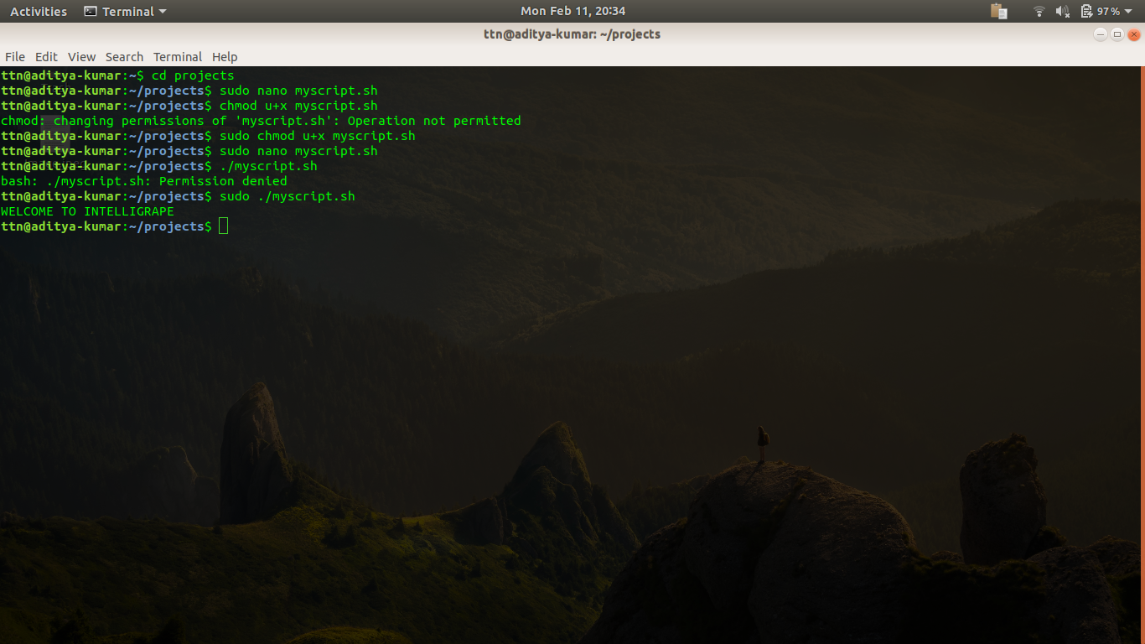
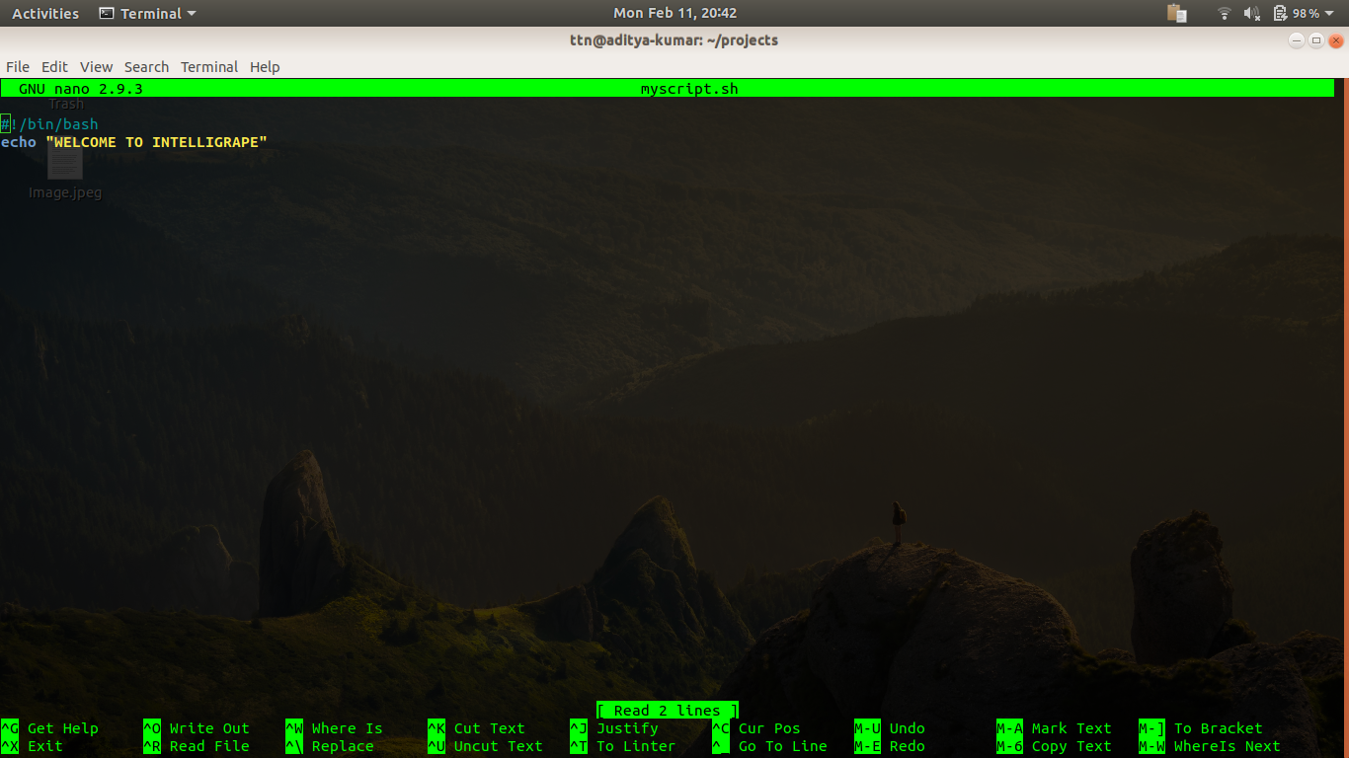

b. <username>@<hostname>:<your present working directory>
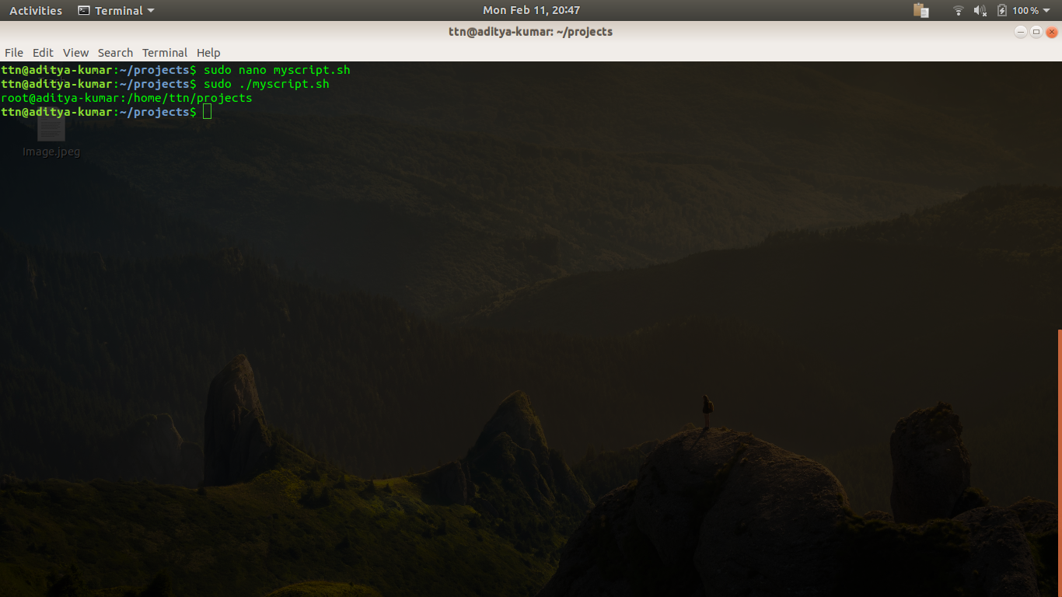
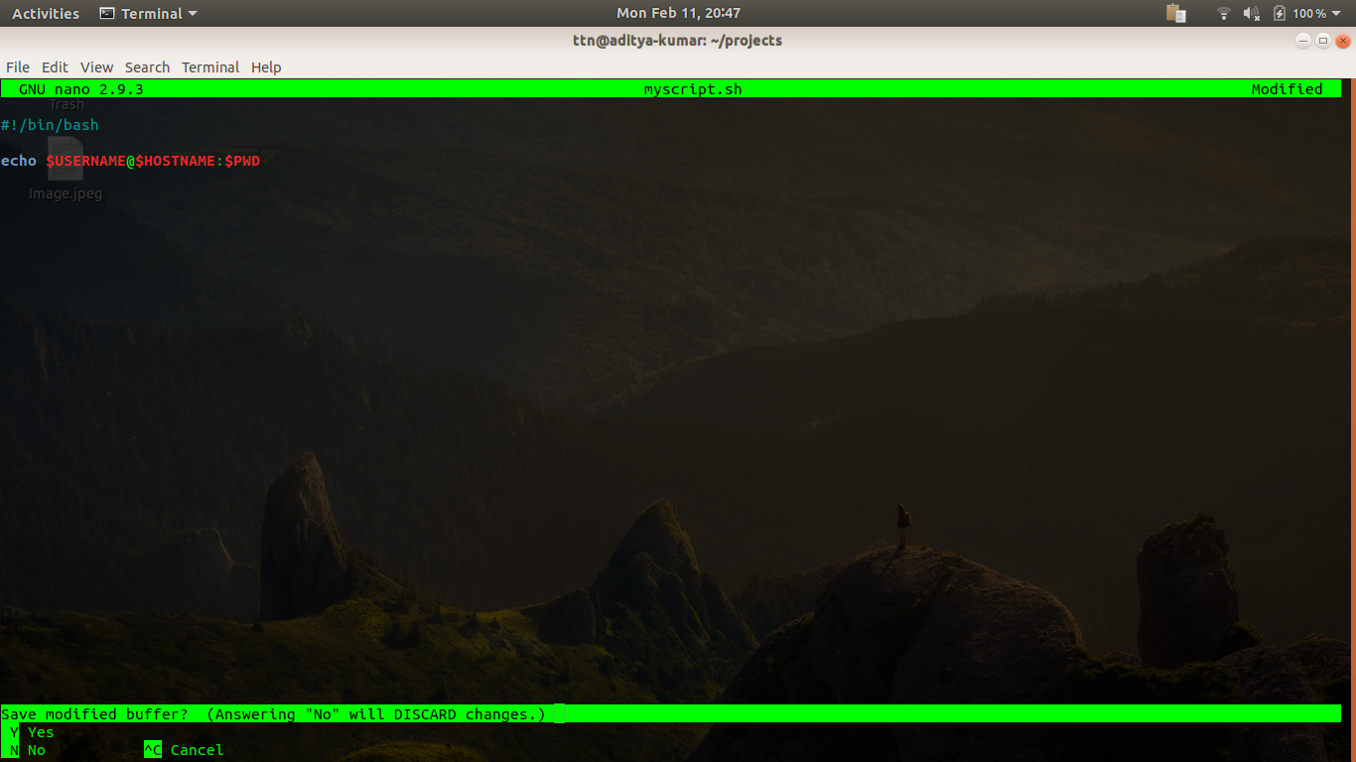

2.(arguments)Write a script
a.which takes in two arguments and print those arguments.
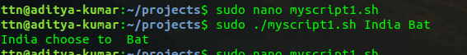

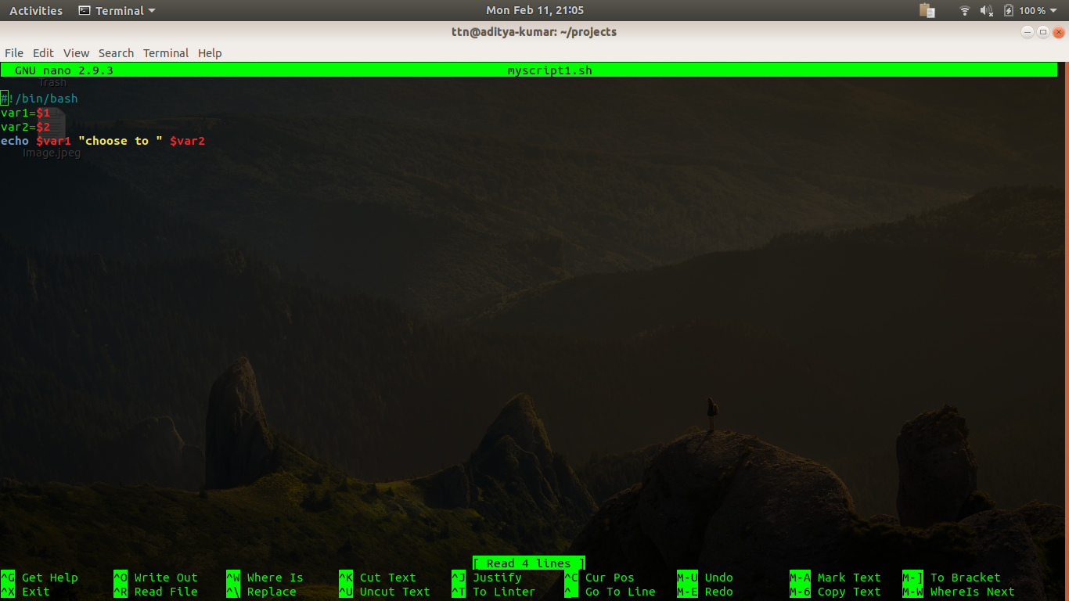

b.which checks the number of arguments passed and if the number is greater than two print ERROR message along with printing the number of arguments.
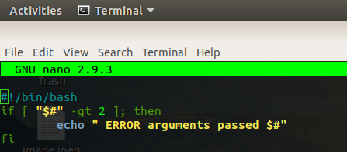

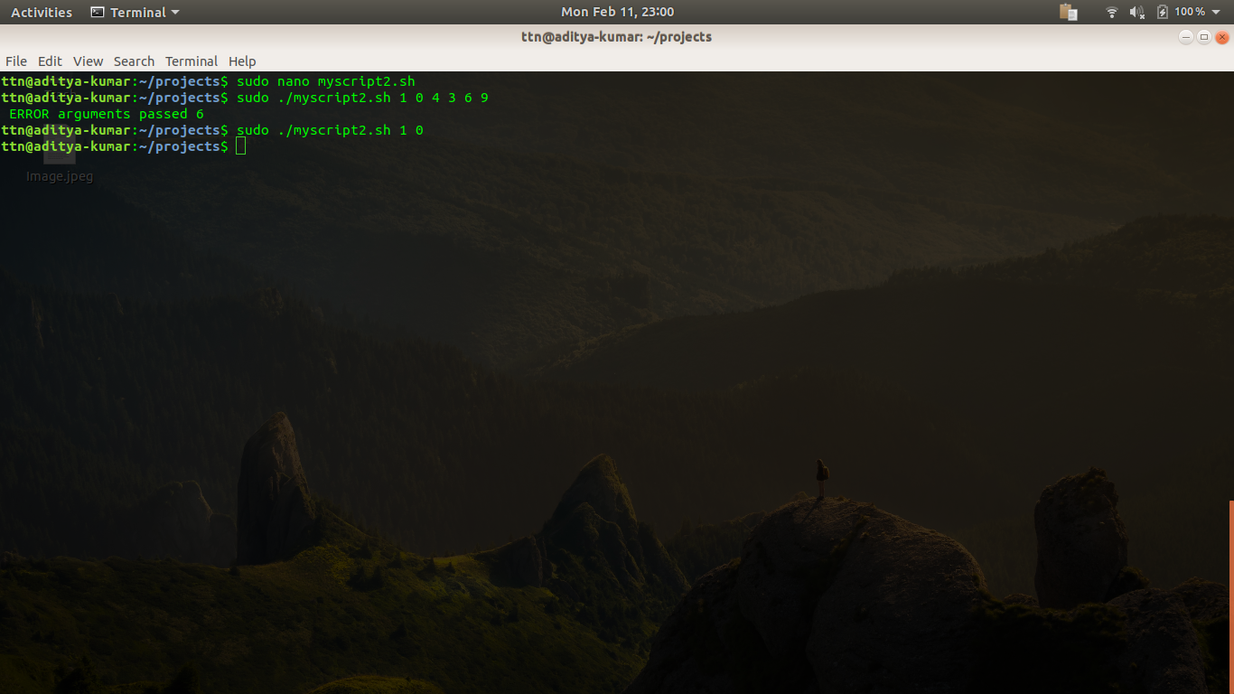
3.Continue with the above script
a.check the two arguments are only integer values and if these are not integers print the proper error on terminal and also log it into a file.
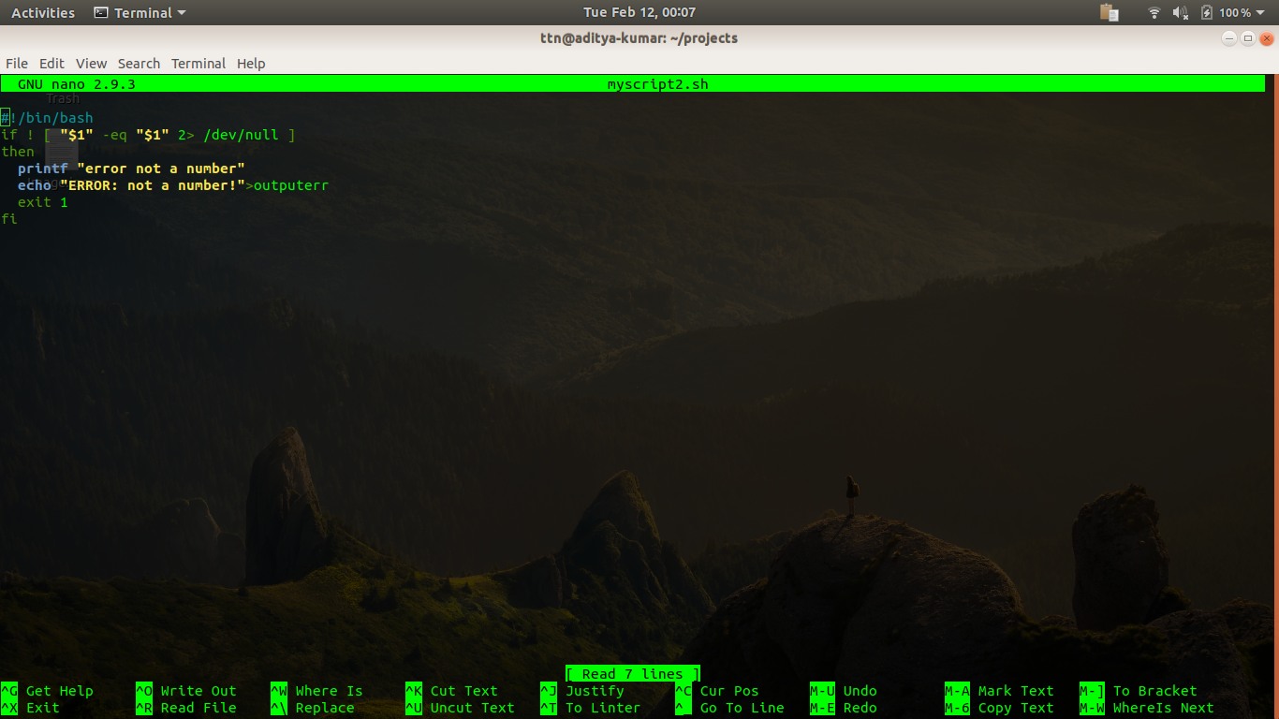
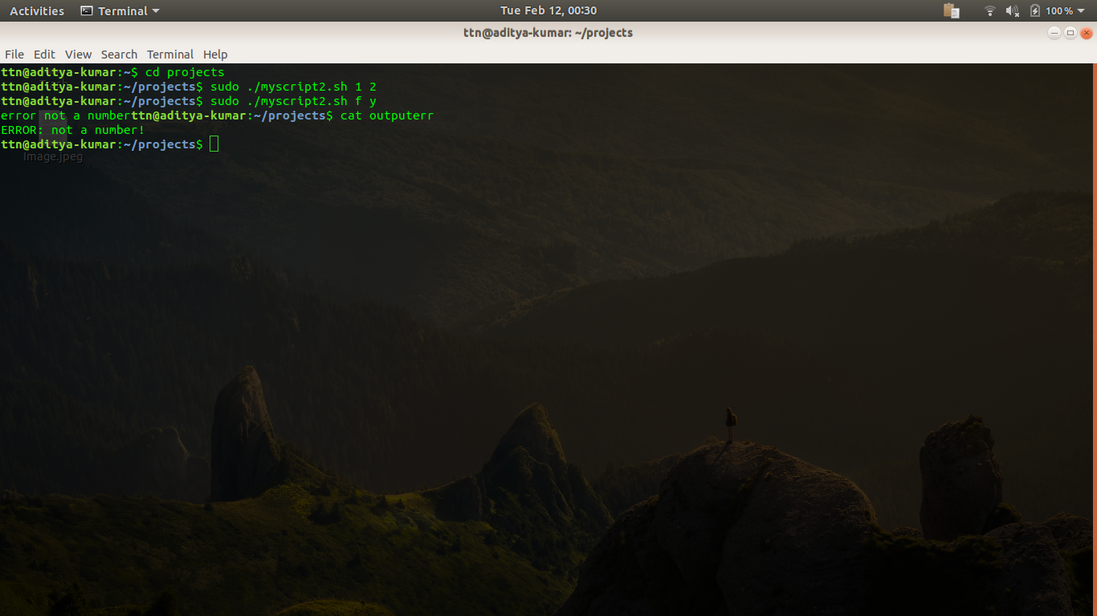
b.perform addition on the two arguments and print result on screen. Use function for this.
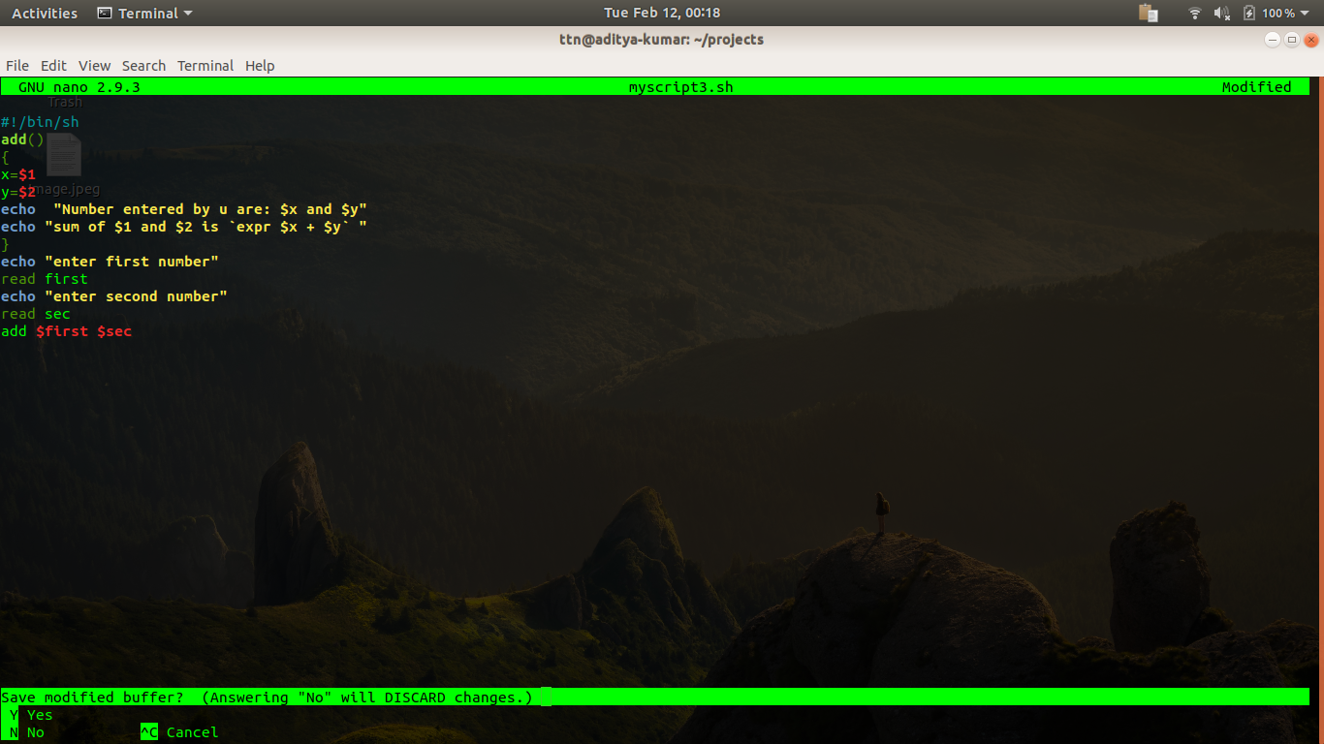
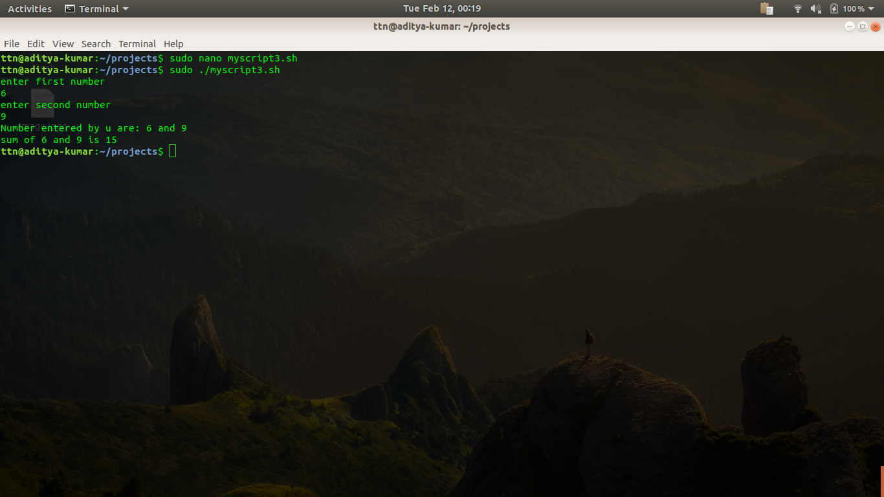
4Create a calculator using the above script which would perform addition,subtraction,division and multliplication.
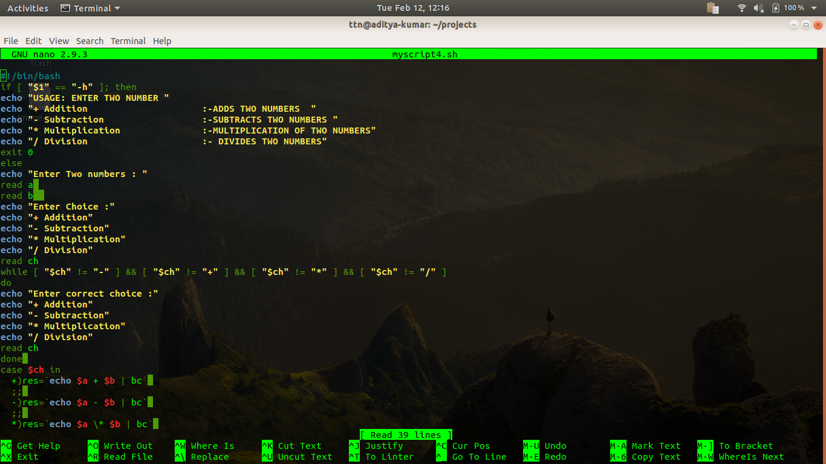
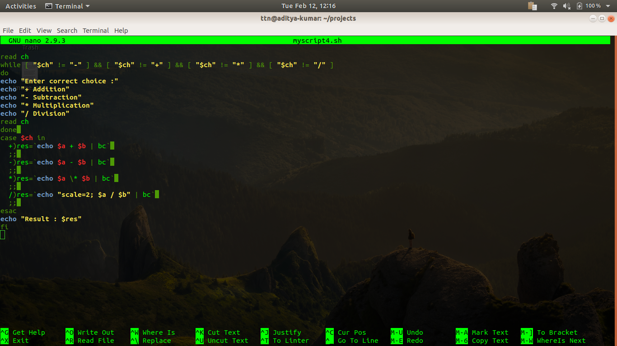
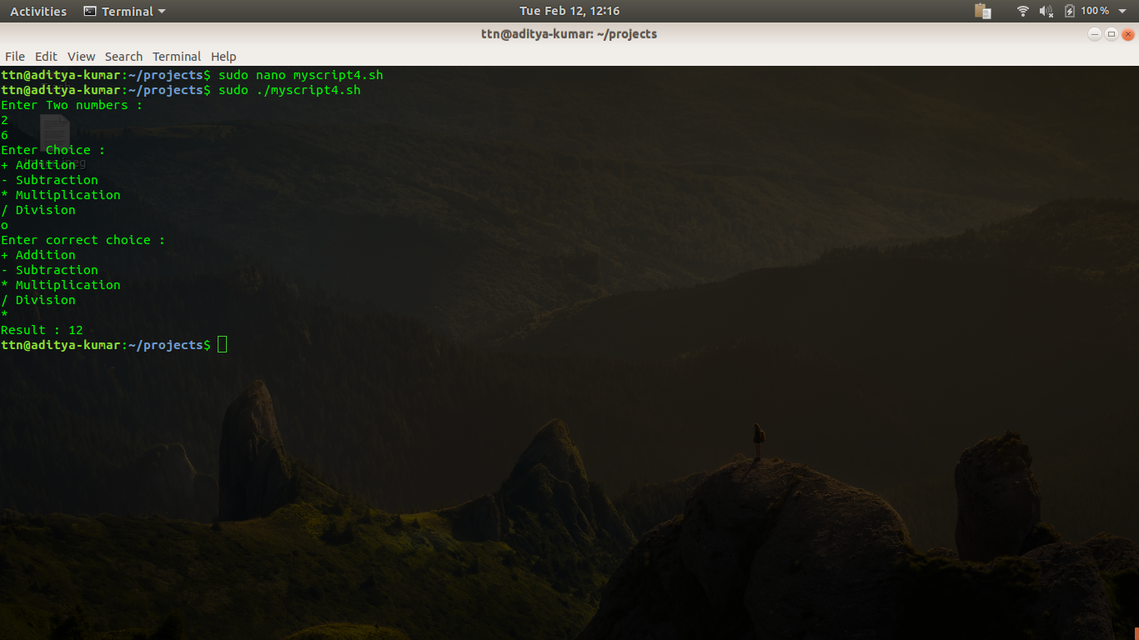

5.Write proper help documentation and print it with -h for above script.

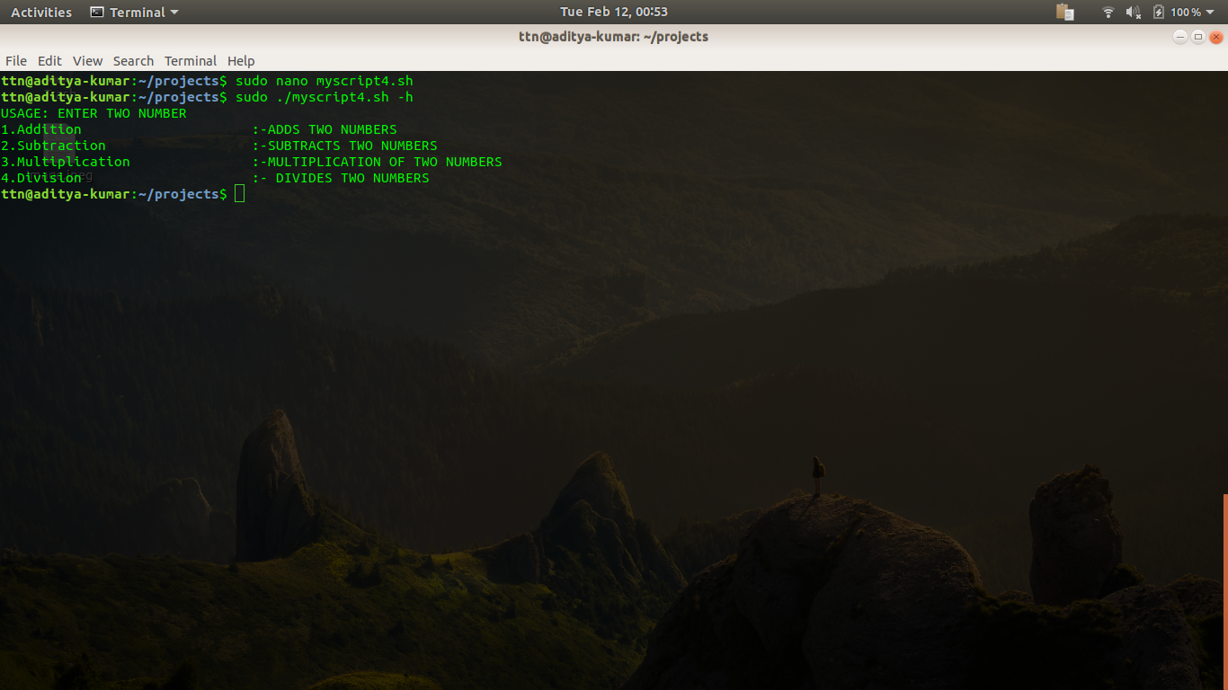

6.Create a script which takes input of "/etc/passwd" file and find out and print the sum of uids and gids. The script should tell which sum of greater.
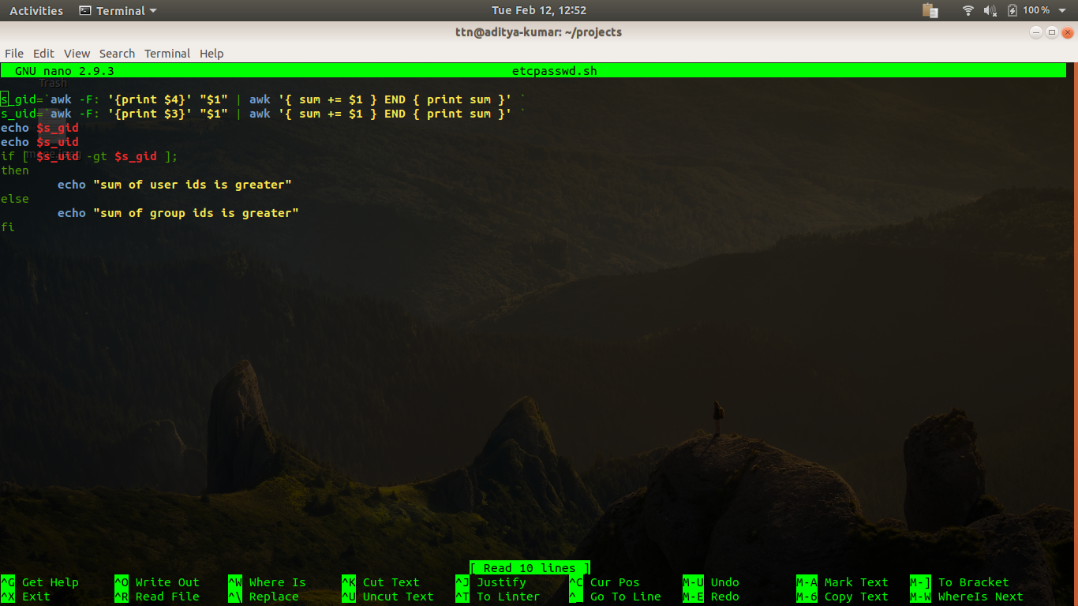
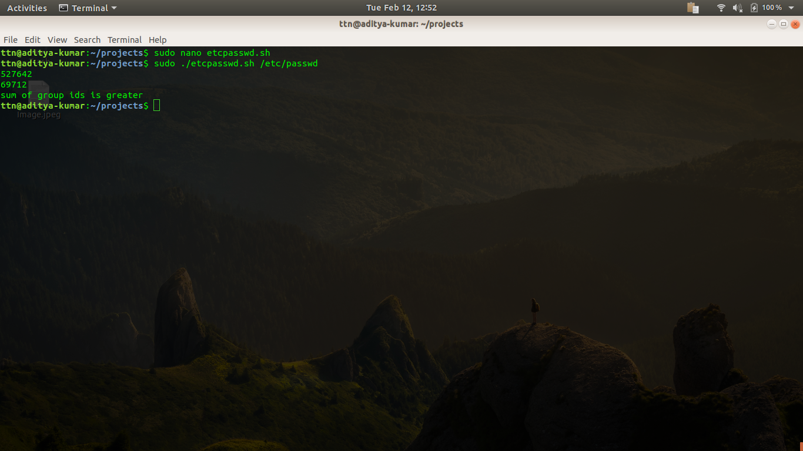

7.A directory contains files and sub-directories. Move files to destination +1 and directories to destination 2
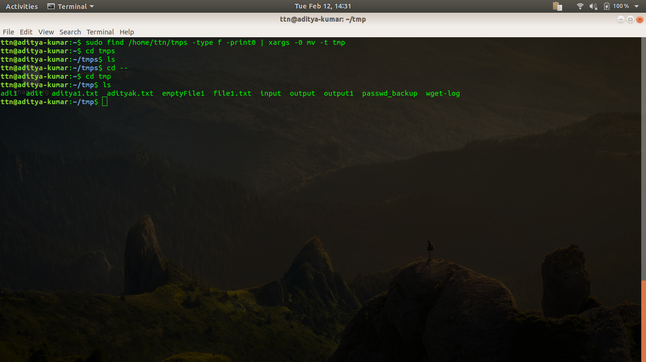
8.Create a script which take three arguments, append first argument to every line in a file and second argument to the end of every line of the same file..
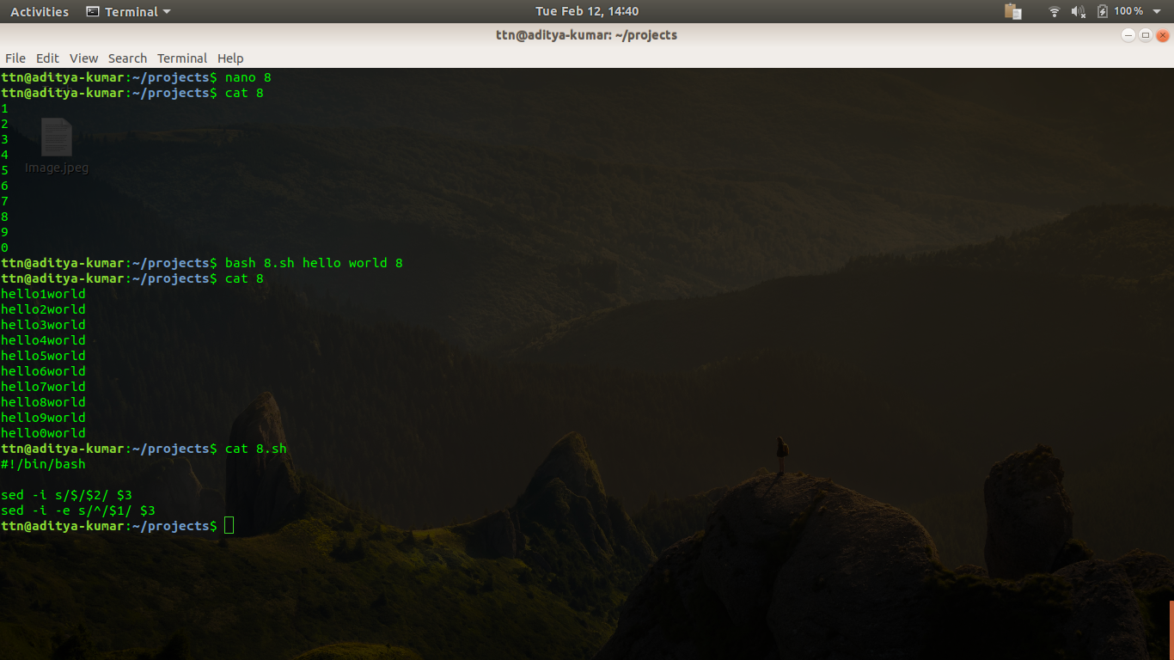

9.Make a list of files in /usr/bin that have the letter "a" as the second character. Put the result in a temporary file.
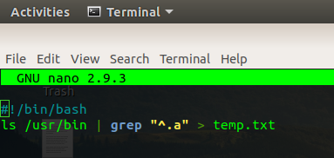
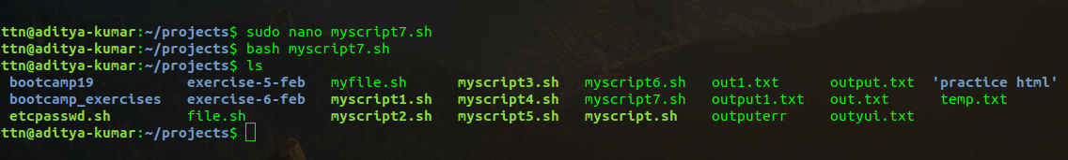

10.List all files in your home directory and print name and size in a table format.


